The American Consulate General in Jerusalem – Public Affairs Office announces

The MEPI Student Leaders Program

June 28 - August 8, 2015

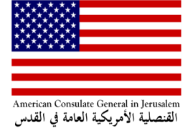
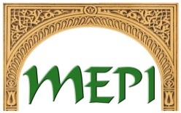

Application Deadline: February 2, 2015

The MEPI Student Leaders Program is a fully-funded six-week intensive leadership training program in the U.S. for undergraduate students from across the Middle East and North Africa. The program runs from June 28 - August 8, 2015, and consists of two key components: a five-week academic residency at a selectedU.S. academicinstitution and a one-week study tour designed to complement and reinforce the concepts explored in the academic residency. MEPI Student Leaders is designed for emerging leaders who demonstrate a commitment to civic engagement in their own communities upon completion of the program.The programconsists of hands-on leadership training workshops, academic sessions on topics including conflict resolution, social and political change management, and the role of civil society in the democratic process, site visits, community service projects, optional home stays and other opportunities for interaction with Americans peers.

Eligible Applicants:
- Palestinian citizens, living and attending universityin the West Bank, Jerusalem or Gaza. Note that applicants should be residing in one of these three areas at the time of application submission and during the interview process.
- Are 20 to 24 years of age;
- Demonstrate strong English language skills needed for participation in a U.S. academic program;
- Are committed to returning to their home country/community following completion of the program;
- Demonstrate strong leadership potential and a commitment to civic engagement;
- Indicate a serious interest in learning about the United States;
- Have a sustained high level of academic achievement;
- Have no prior travel experience in the United States and limited to no study or travel experience outside their home country;
- Are willing and able to participate fully in intensive academic, community service, and educational travel activities;
- Are comfortable with campus life, sharing living accommodations while traveling with a multinational group of participants from the Middle East and North Africa and with U.S. citizens, and making adjustments to cultural and social practices different from those of their home countries/communities; and
- Are comfortable spending Ramadan and Eid in the United States.
- U.S. passport and L.P.R. (green card) holders are ineligible to apply.

Application Deadline and inquiries:
Please submit a copy of your passport, CV, and applicationform by February 2, 2015.
Jerusalem and West Bank Applicants: Email completed application packages to exchanges@state.gov; call 02-622-7172 or (0545) 420 953 for more information.
Gaza Applicants: Email completed application packages to GazaExchanges@gmail.com; call 08-286-4623, or 059-967-7317 for more information.
The details and application for the program can be found at the following site:
http://jerusalem.usconsulate.gov/educational_exchange.html.

